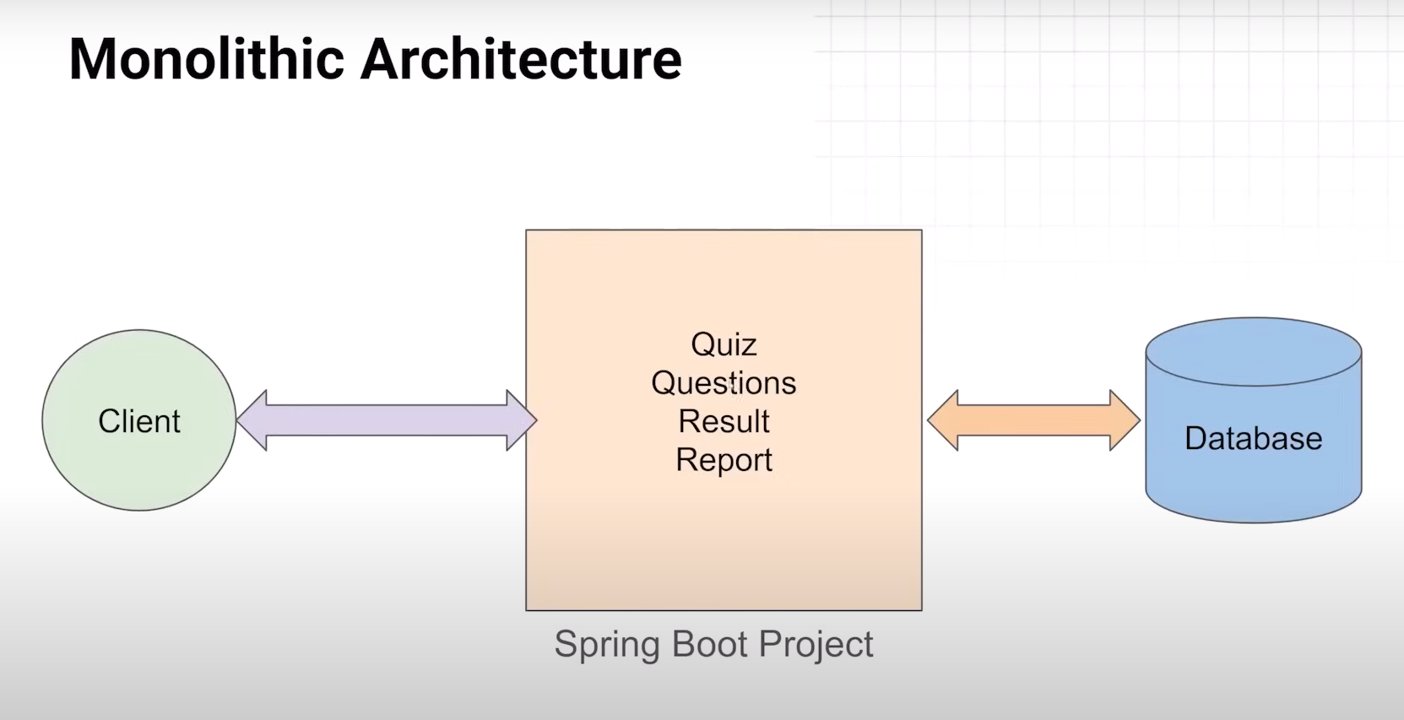

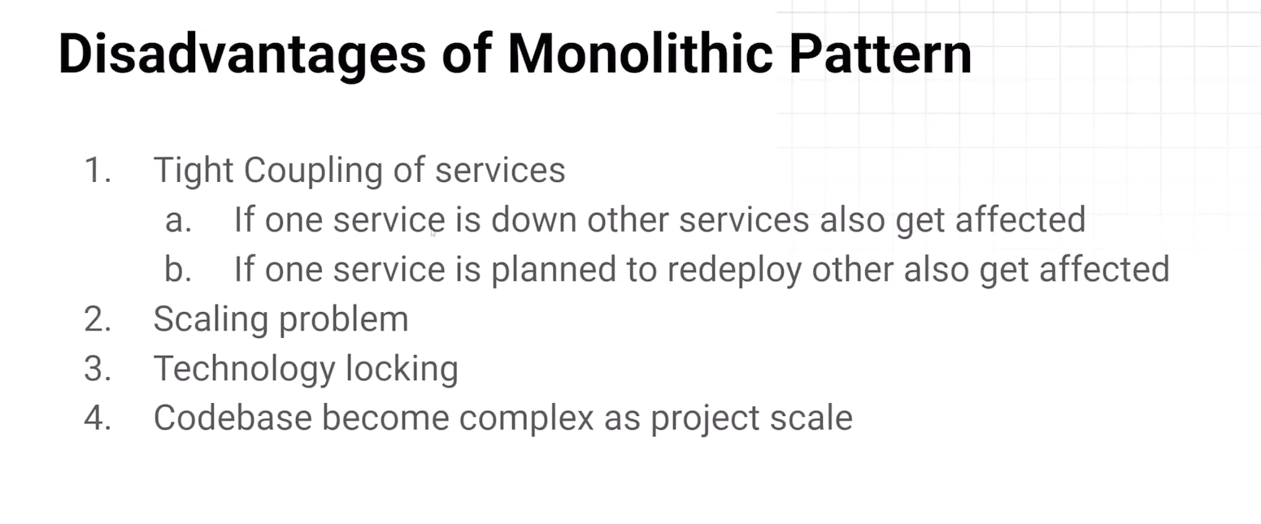

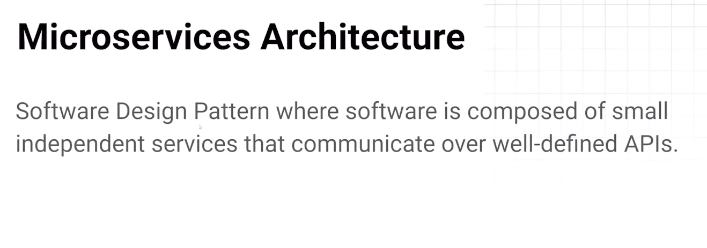

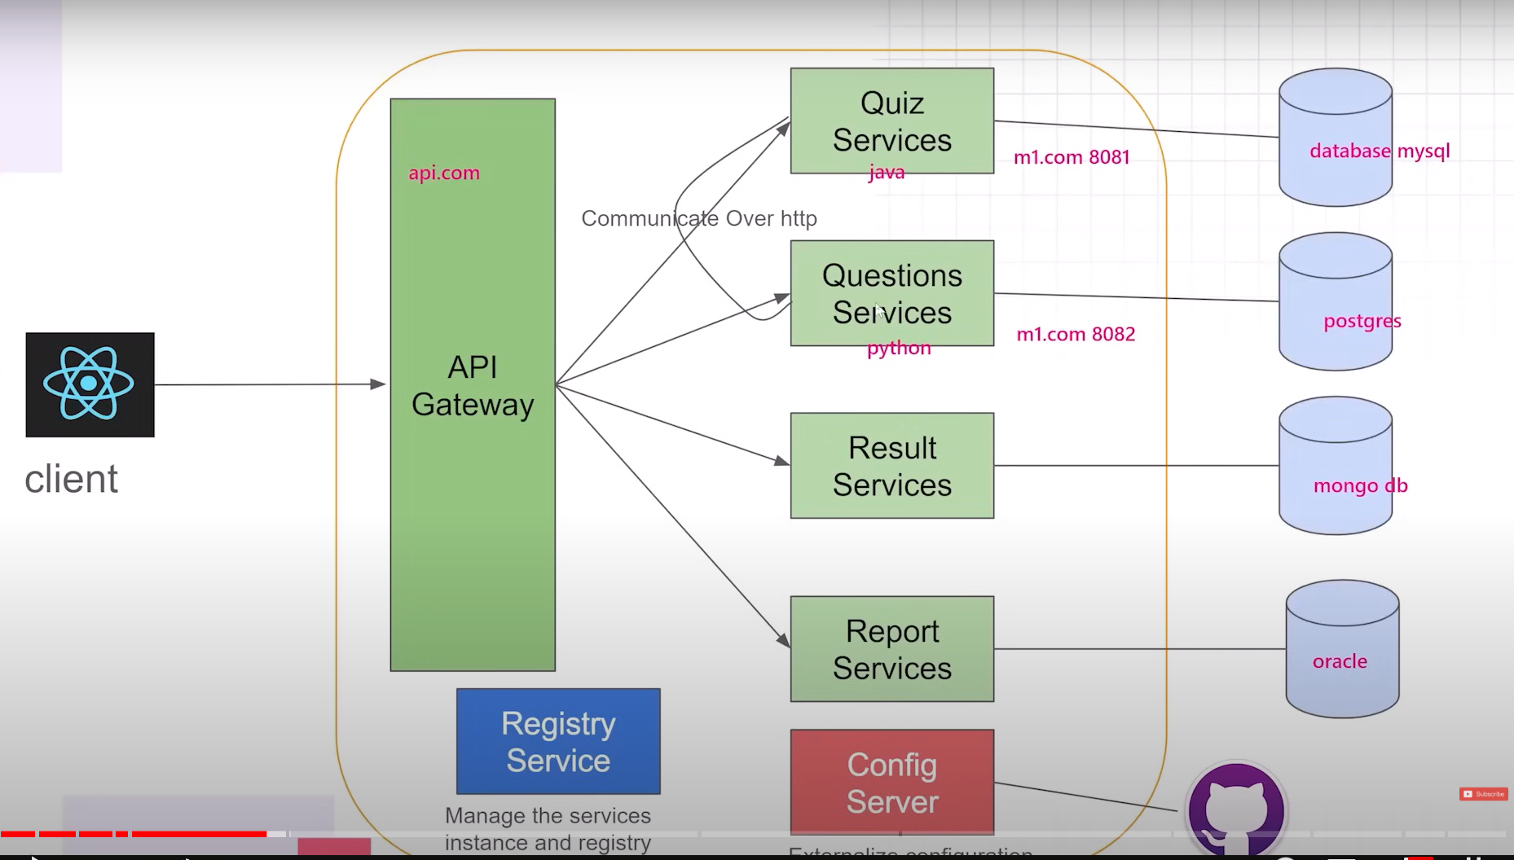

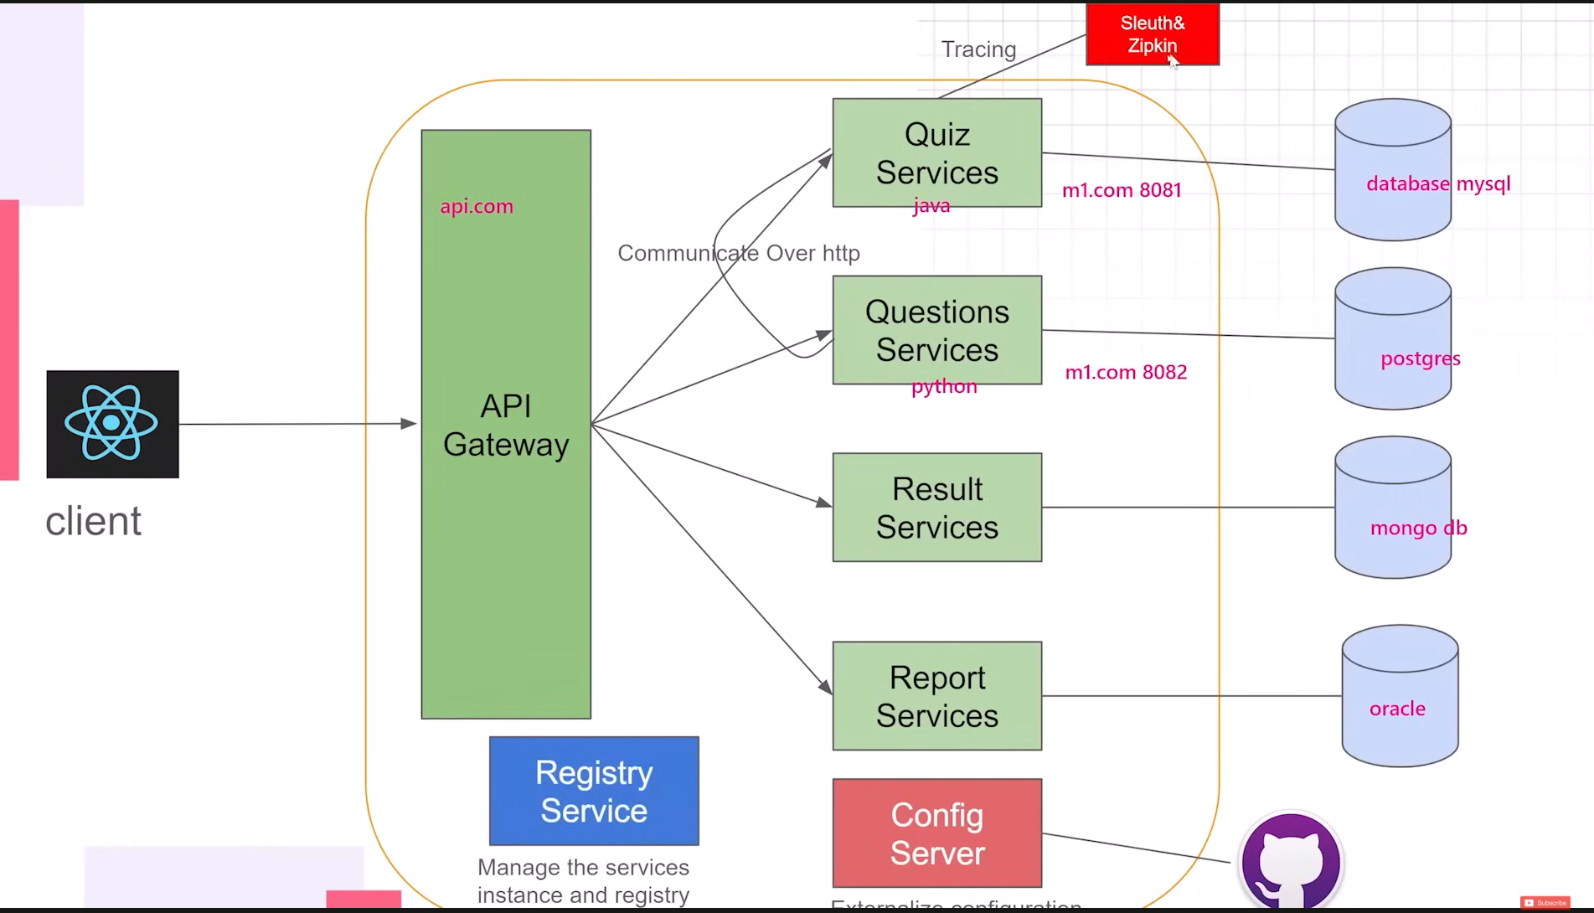

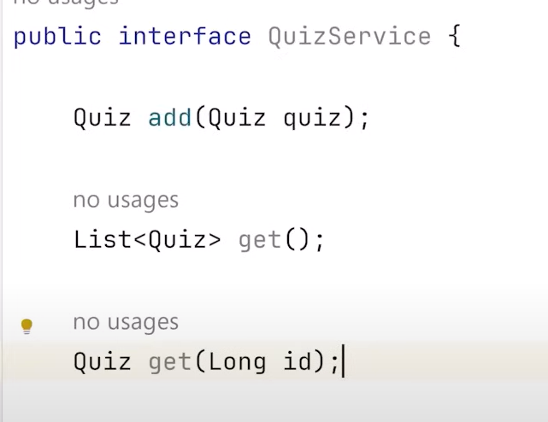

Communications between quiz and question services.

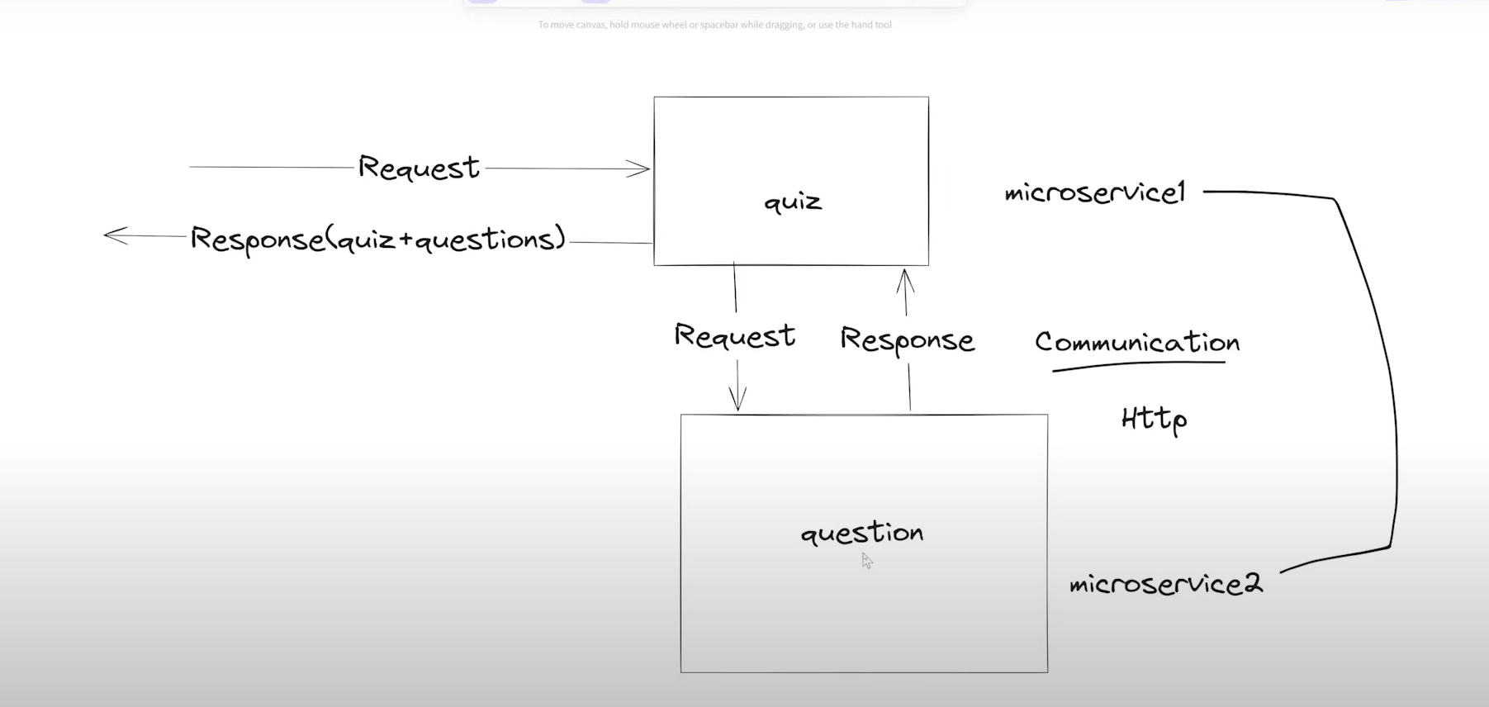

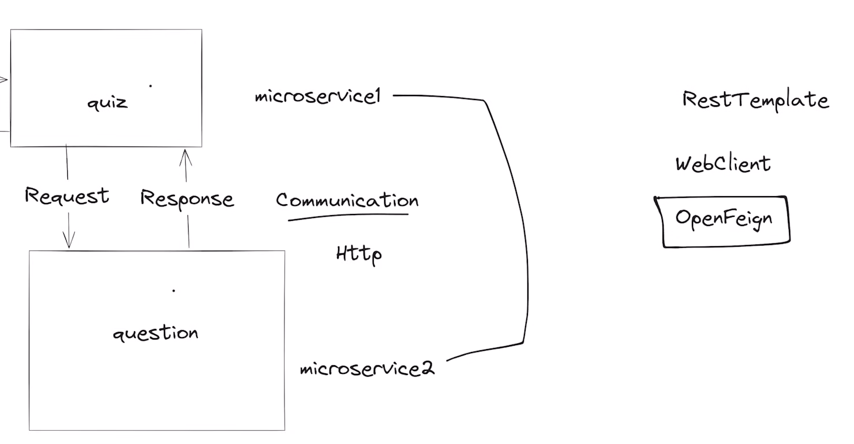

Now communication between quiz service and question service.

Walk through below link and understand.

<https://docs.spring.io/spring-framework/docs/current/javadoc-api/org/springframework/web/client/RestTemplate.html>

<https://spring.io/projects/spring-cloud-openfeign/>

Step:1 open spring initializer and Search dependency “openFeign” and click then click on explore.

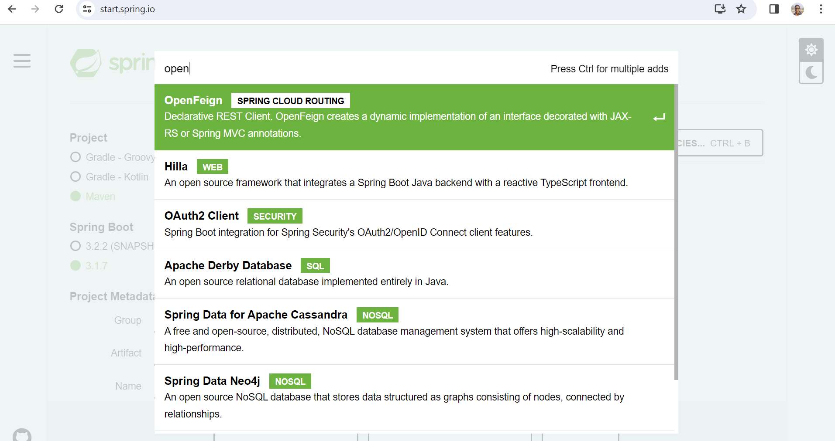

**Add dependency in quizService like below.**

Add dependency management.

<dependencyManagement>

<dependencies>

<dependency>

<groupId>org.springframework.cloud</groupId>

<artifactId>spring-cloud-dependencies</artifactId>

<version>${spring-cloud.version}</version>

<type>pom</type>

<scope>import</scope>

</dependency>

</dependencies>

</dependencyManagement>

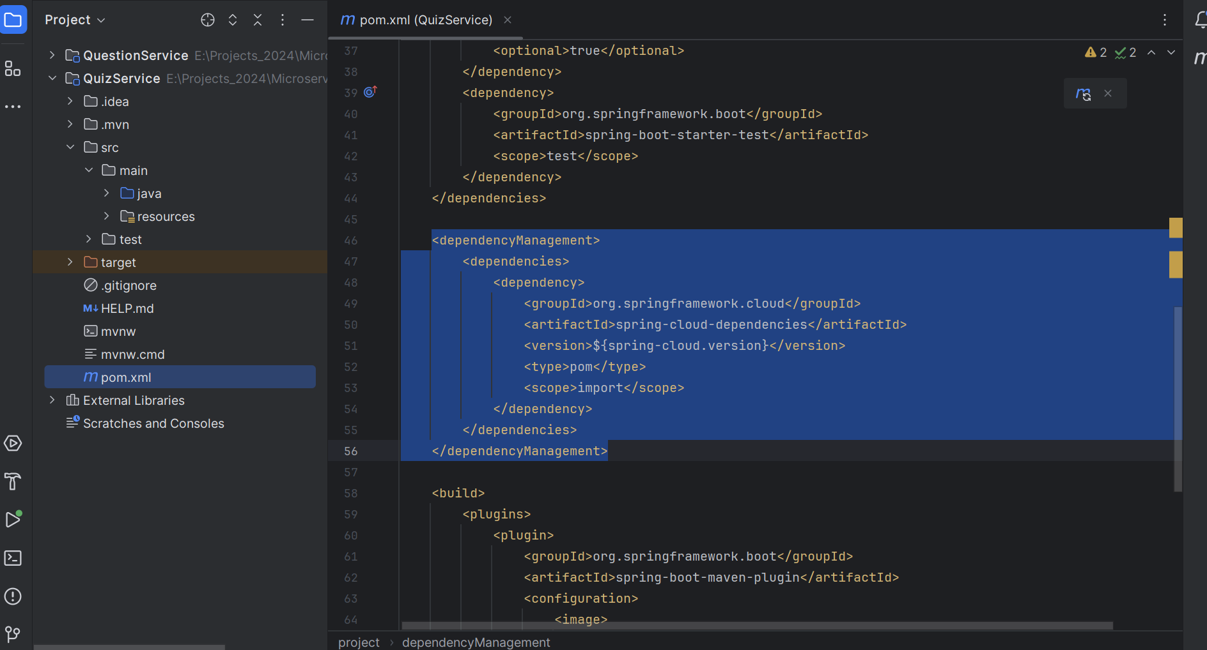

Add version

<spring-cloud.version>2022.0.4</spring-cloud.version>

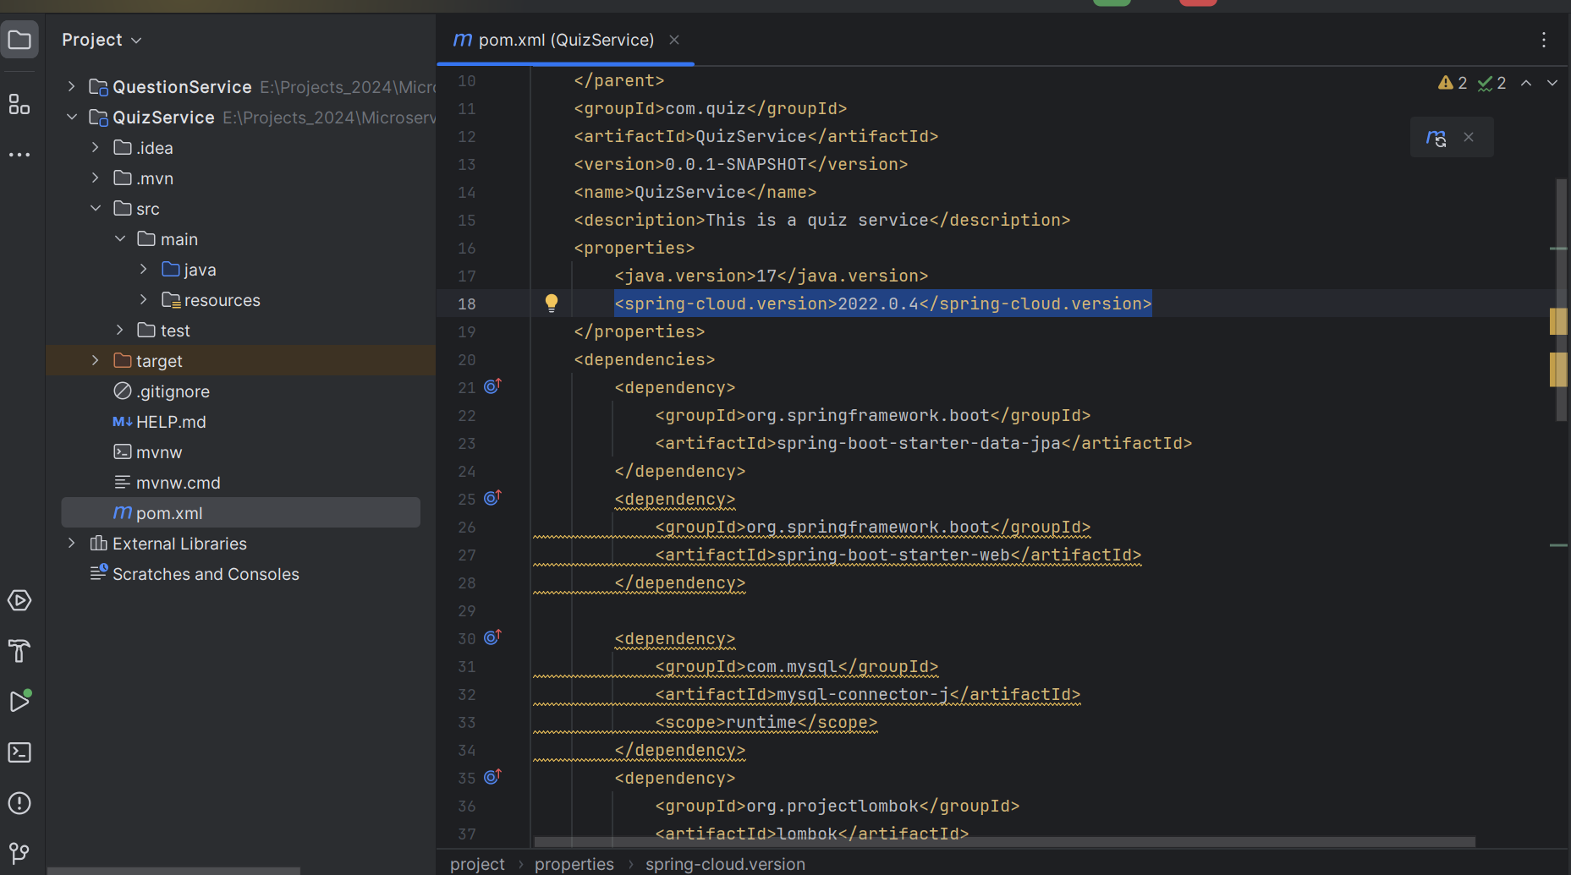

Add openfeign dependency

<dependency>

<groupId>org.springframework.cloud</groupId>

<artifactId>spring-cloud-starter-openfeign</artifactId>

</dependency>

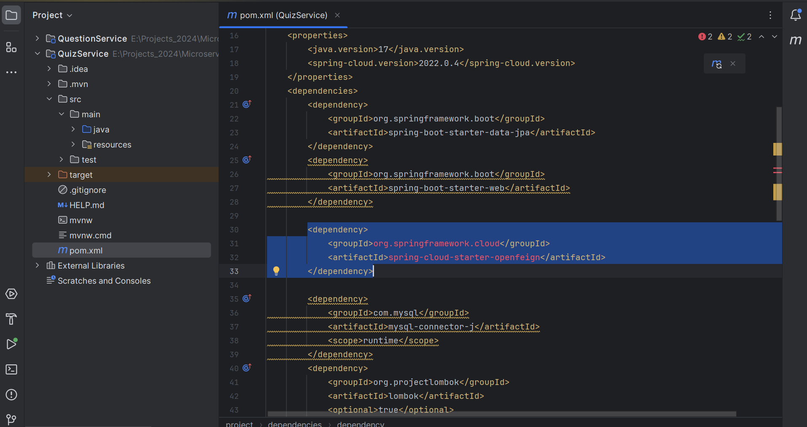

Create one entity class in quiz Service inside entity package

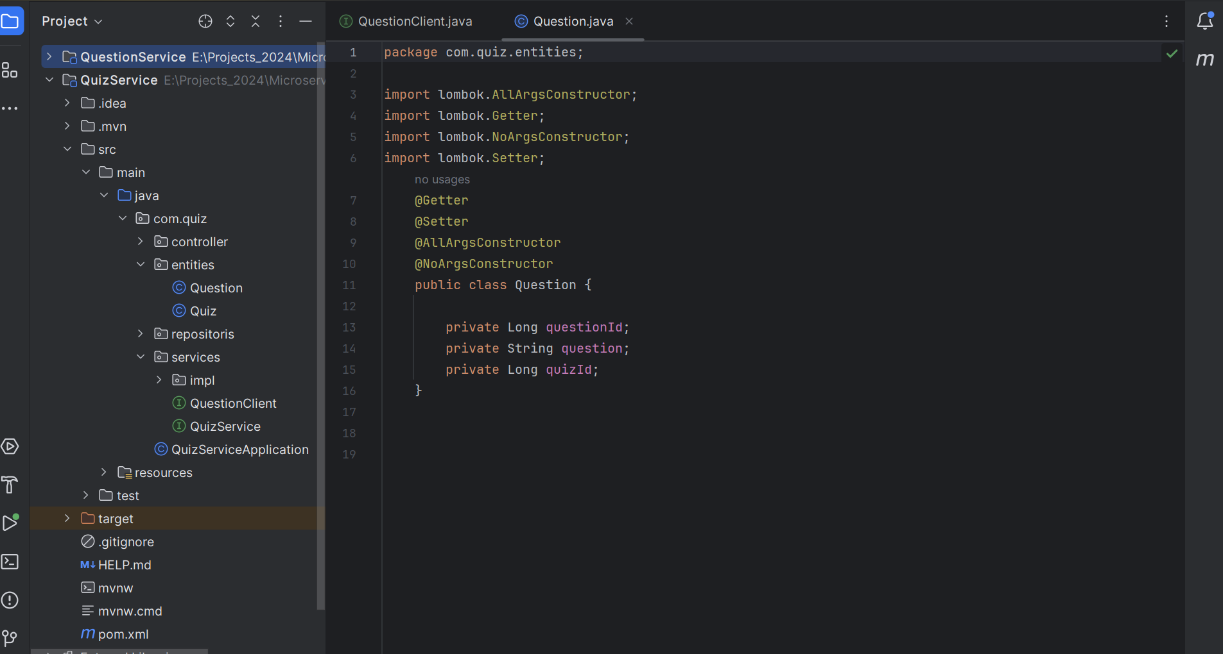

Create one Interface **QuestionClient.**

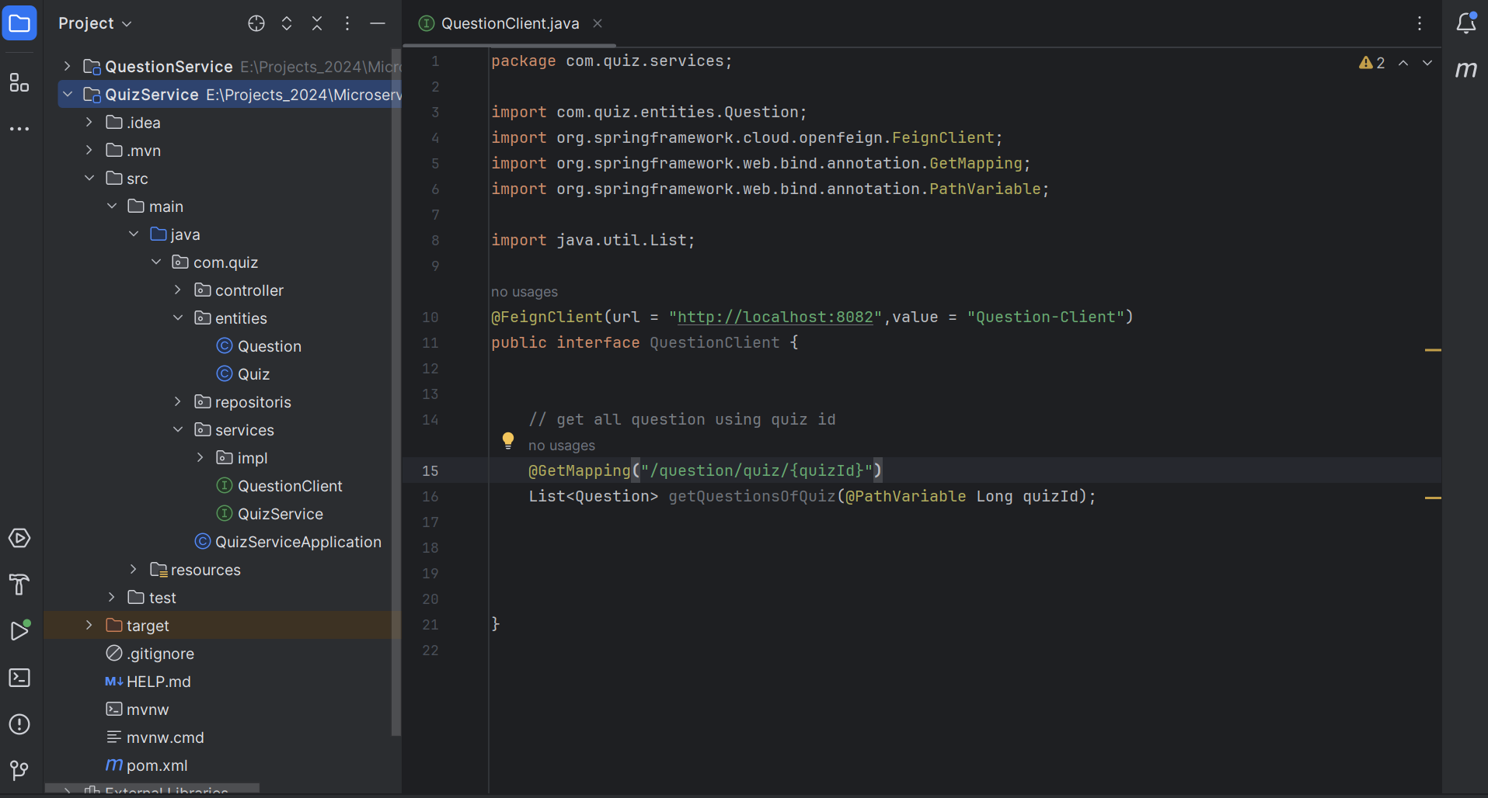

Enable Feign client to add annotation **@EnableFeignClient.**

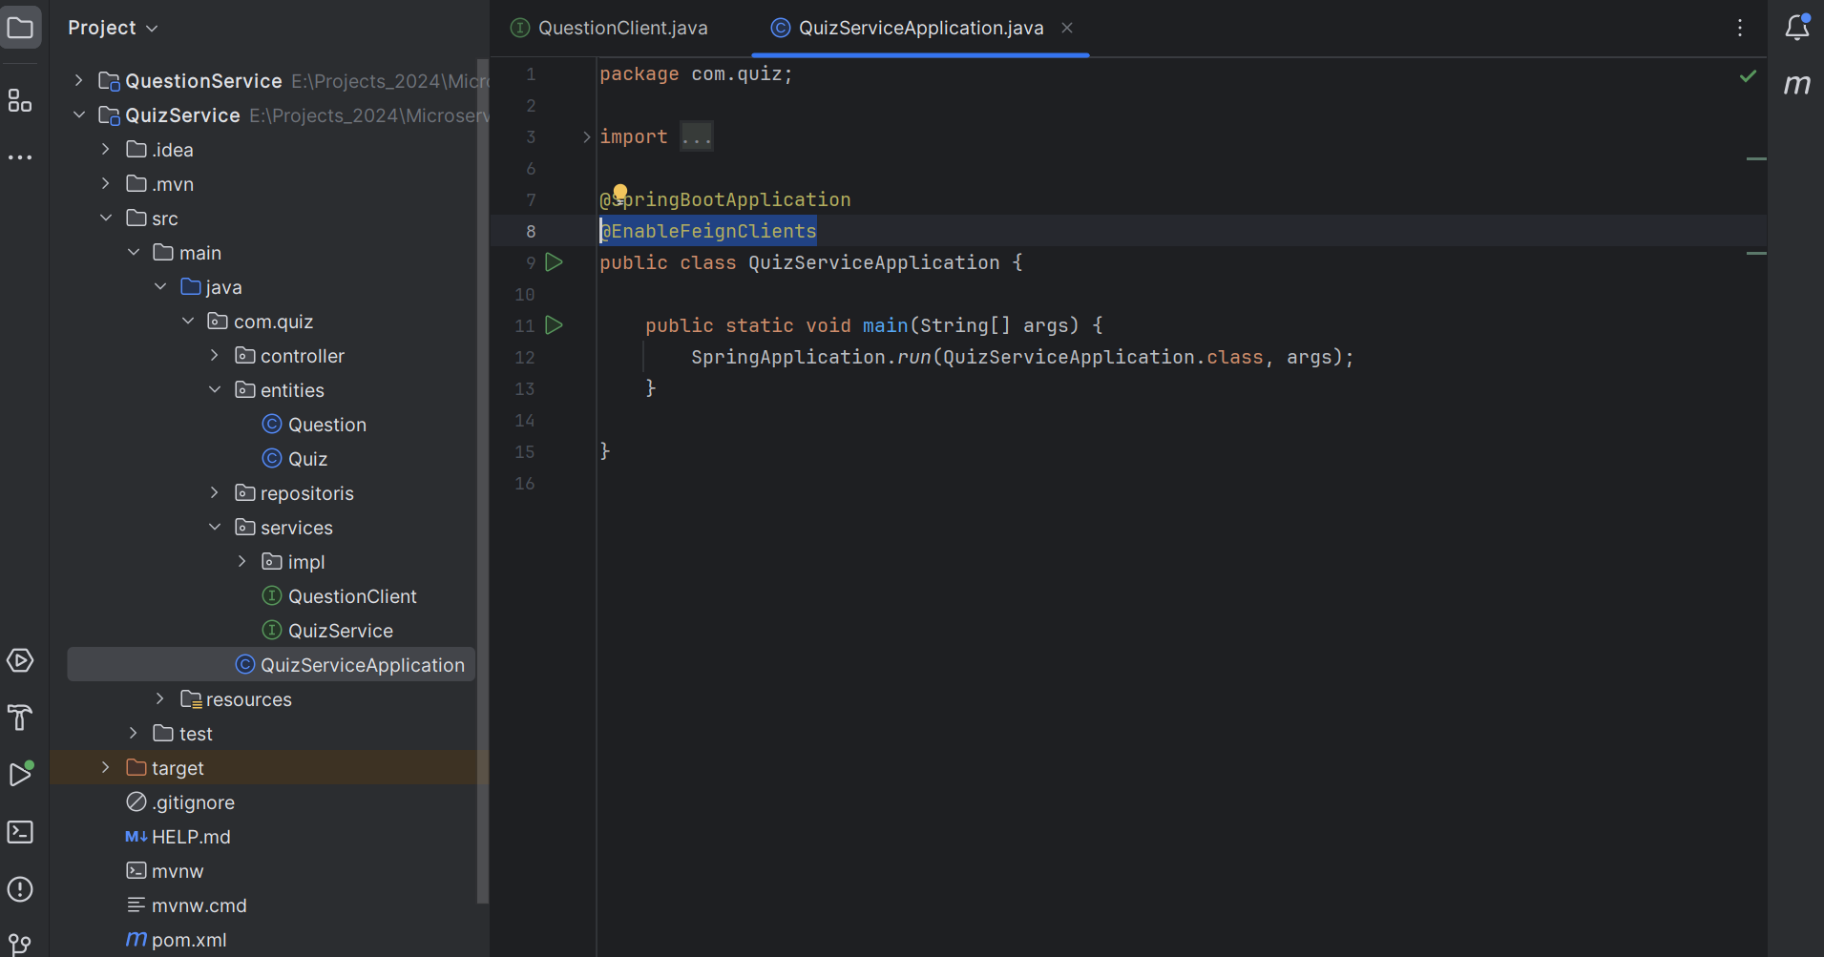

Add List of question inside quiz entity and make it transient.

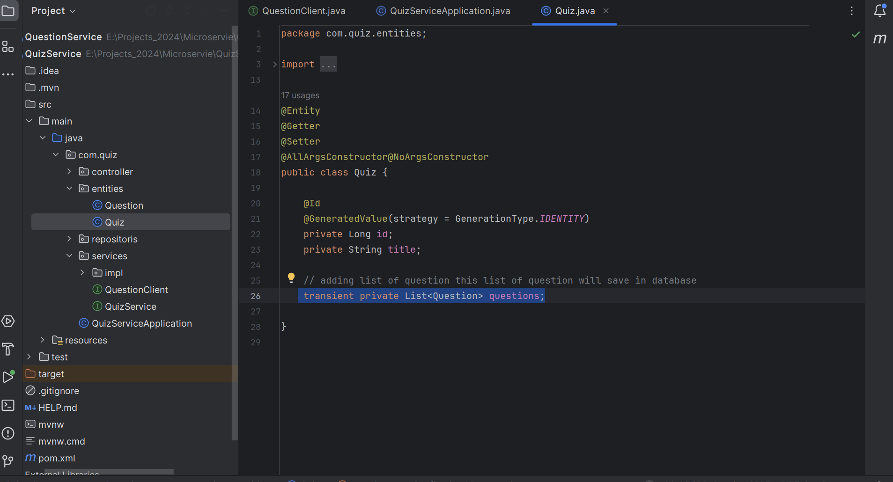

Autowired questionClient.

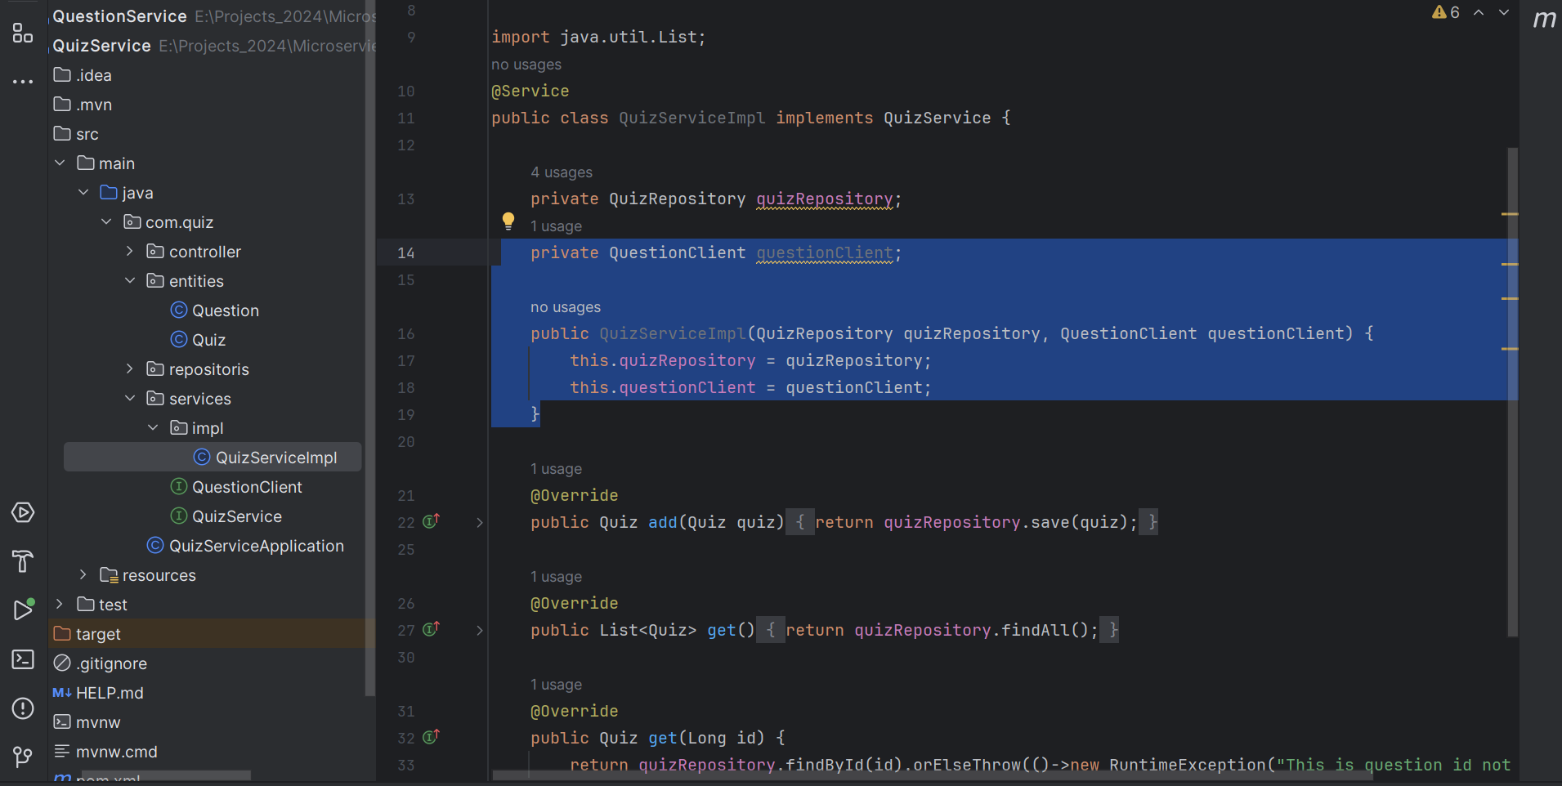

Implement QuizServiceImpl

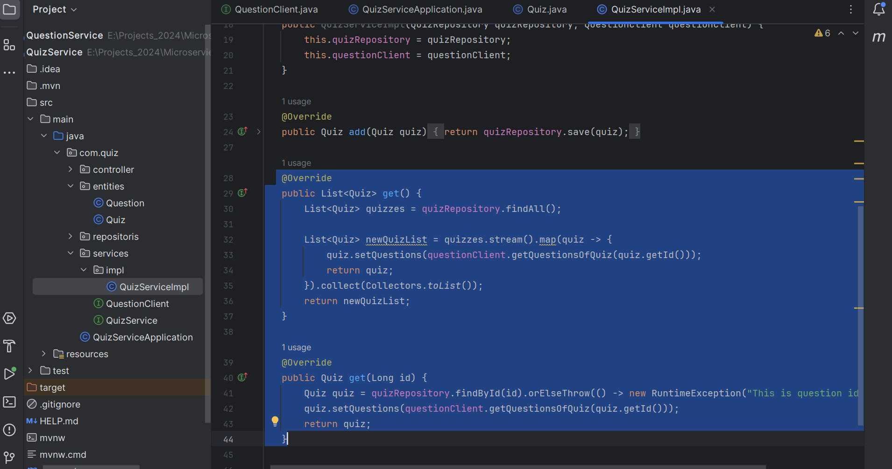

Now test it

GET: http://localhost:8081/quiz

GET: <http://localhost:8081/quiz/1>

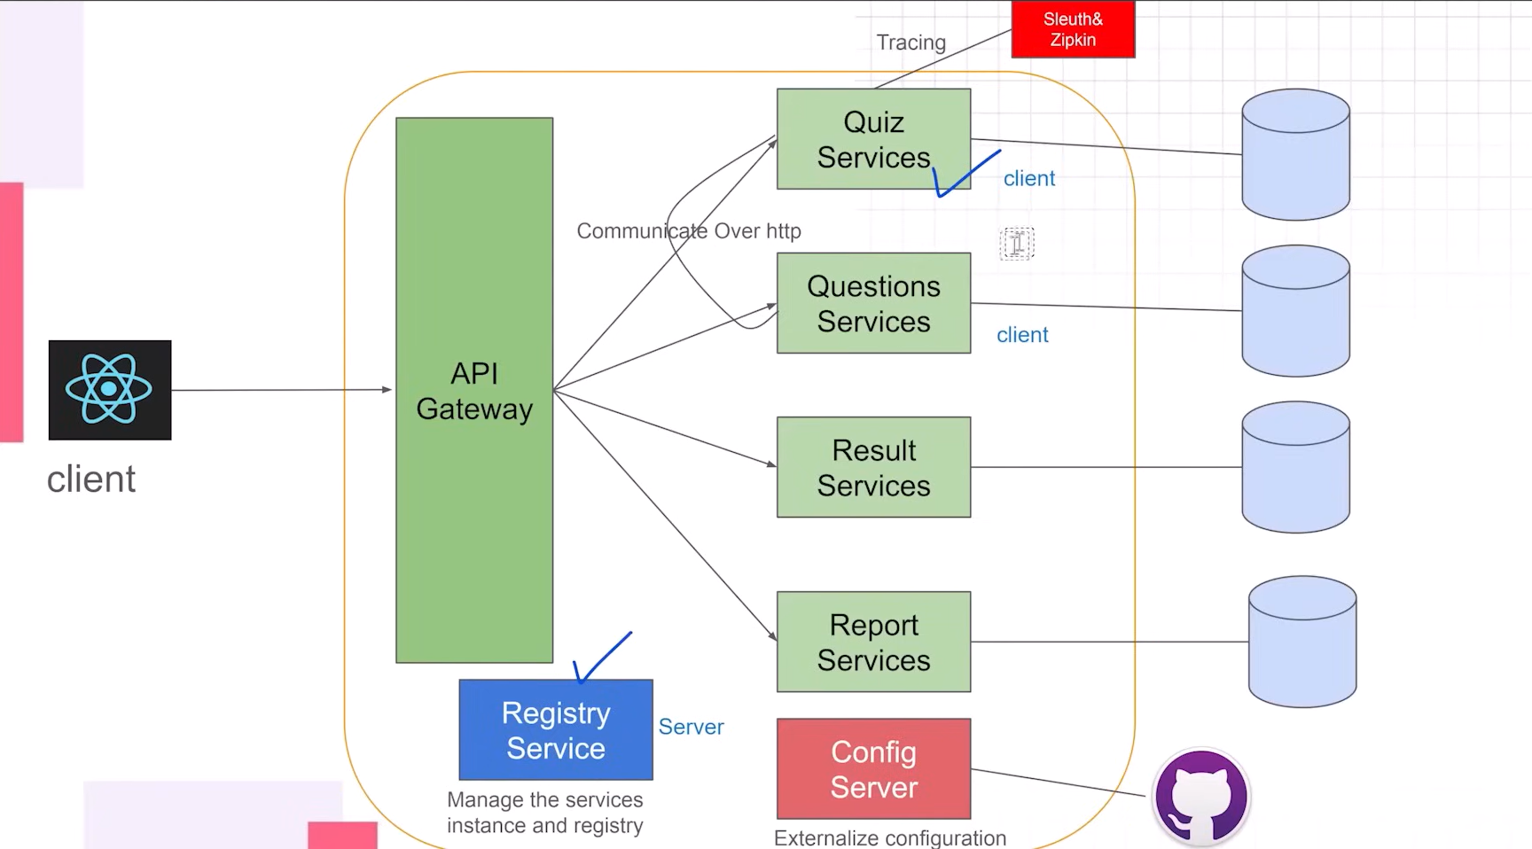

Create Service Registry (Discovery service)

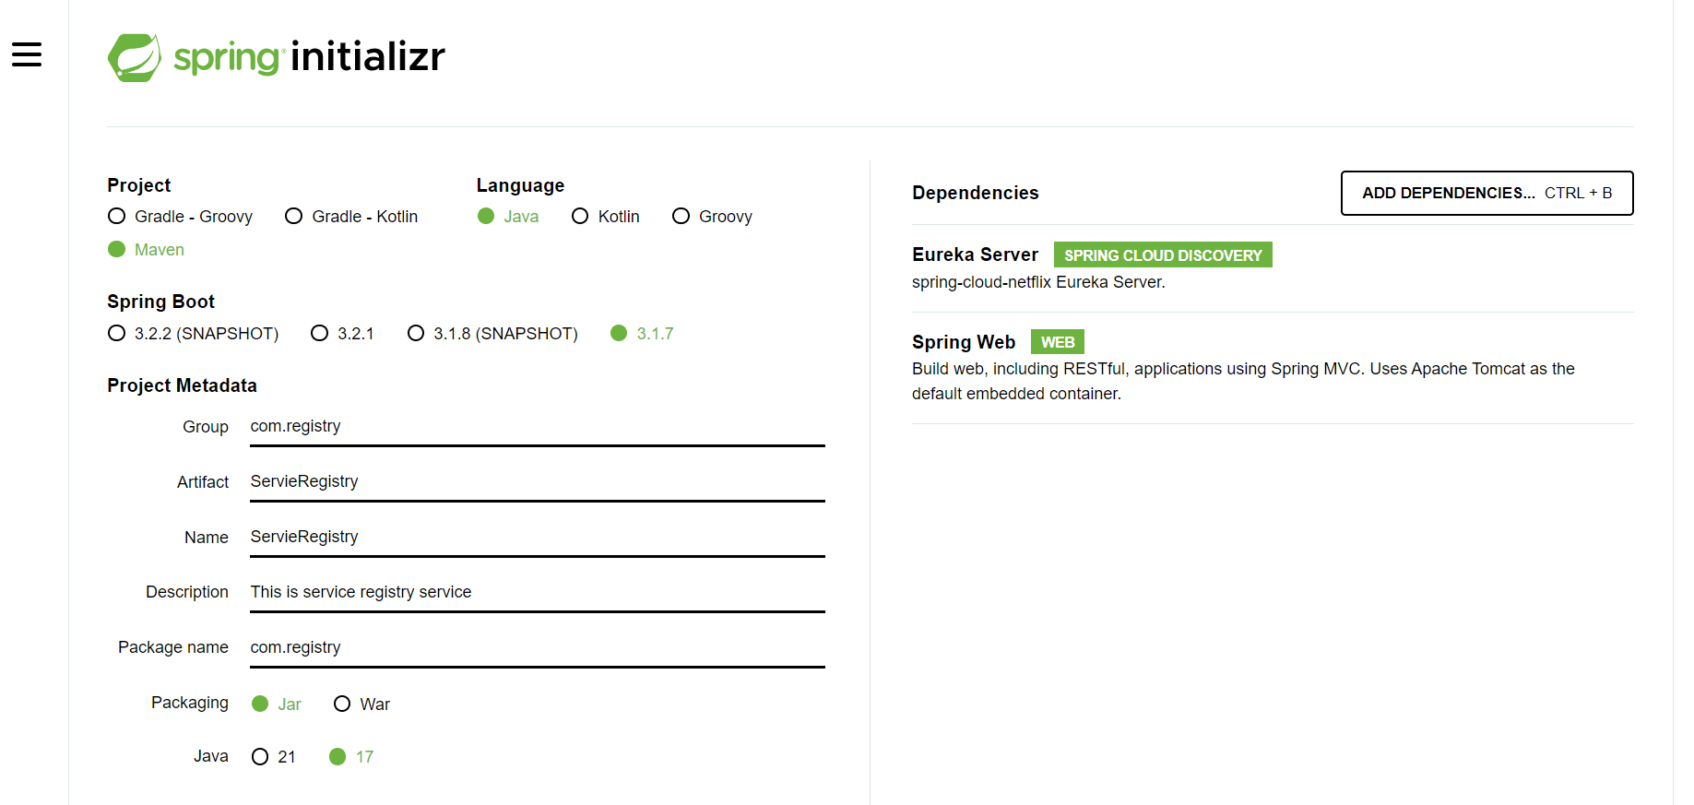

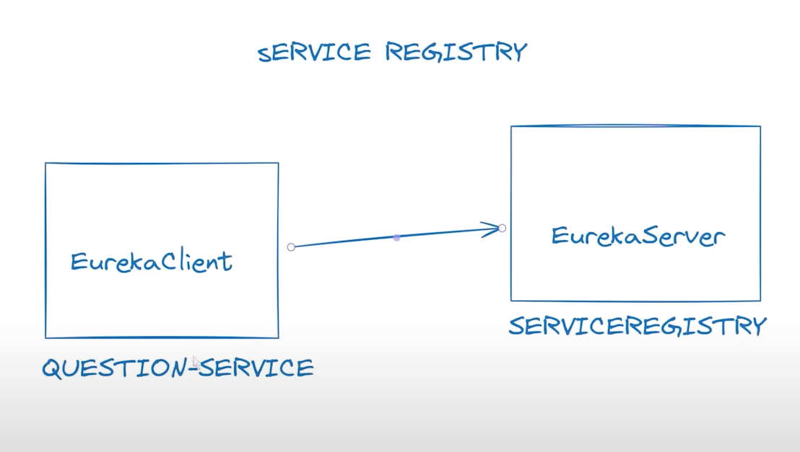

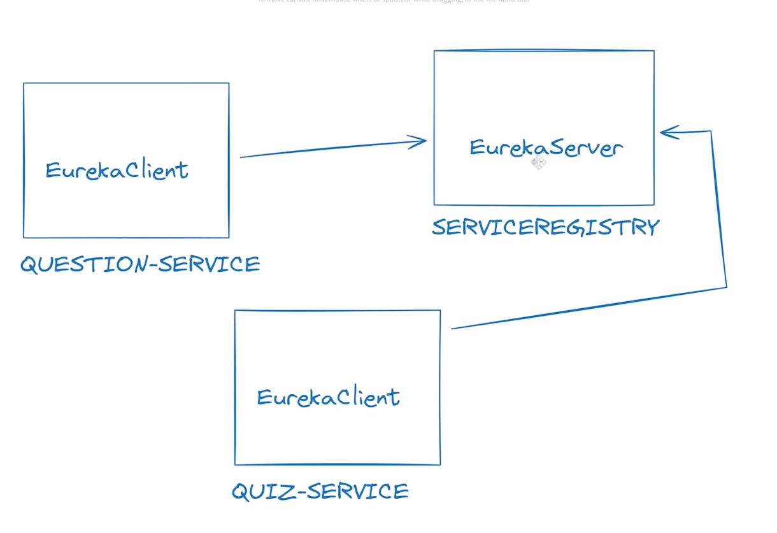

Eureka server URL: <http://localhost:8761/eureka/>

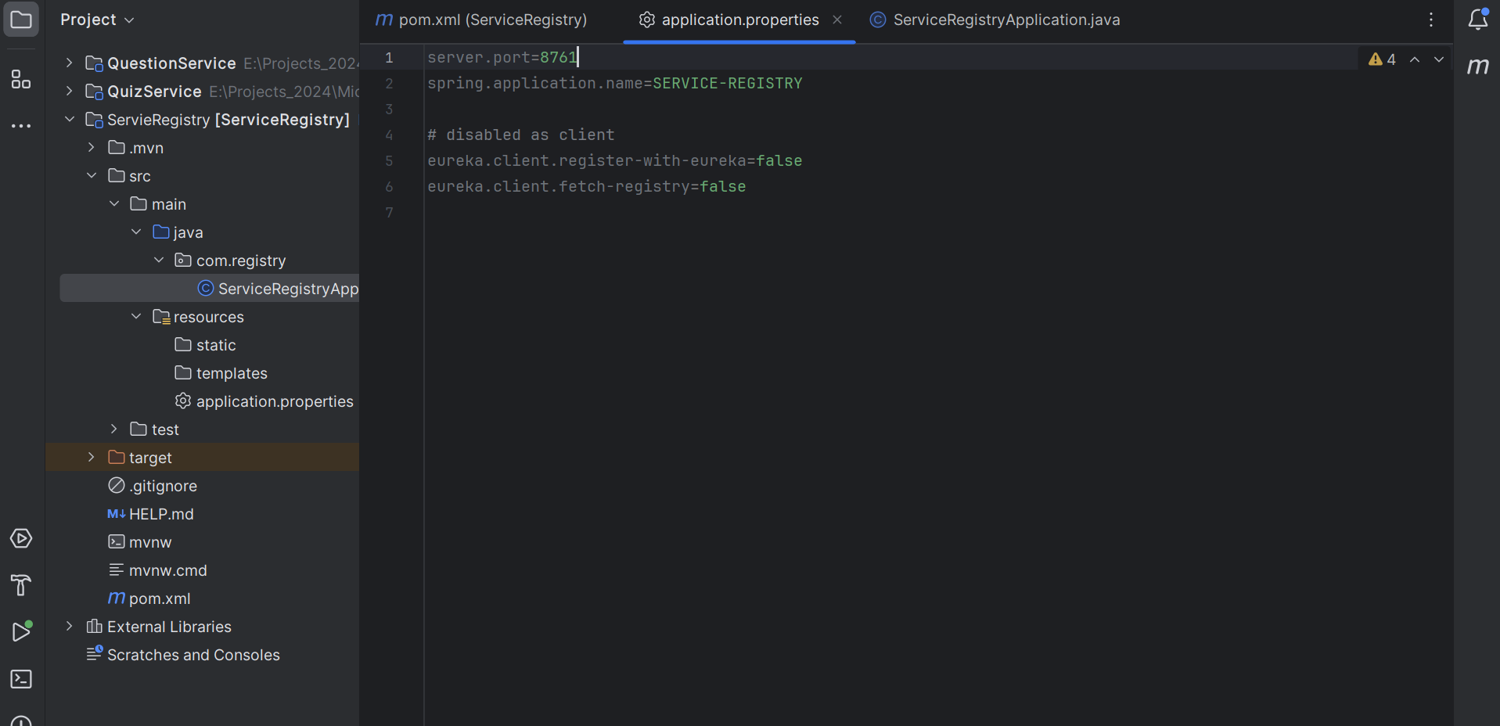

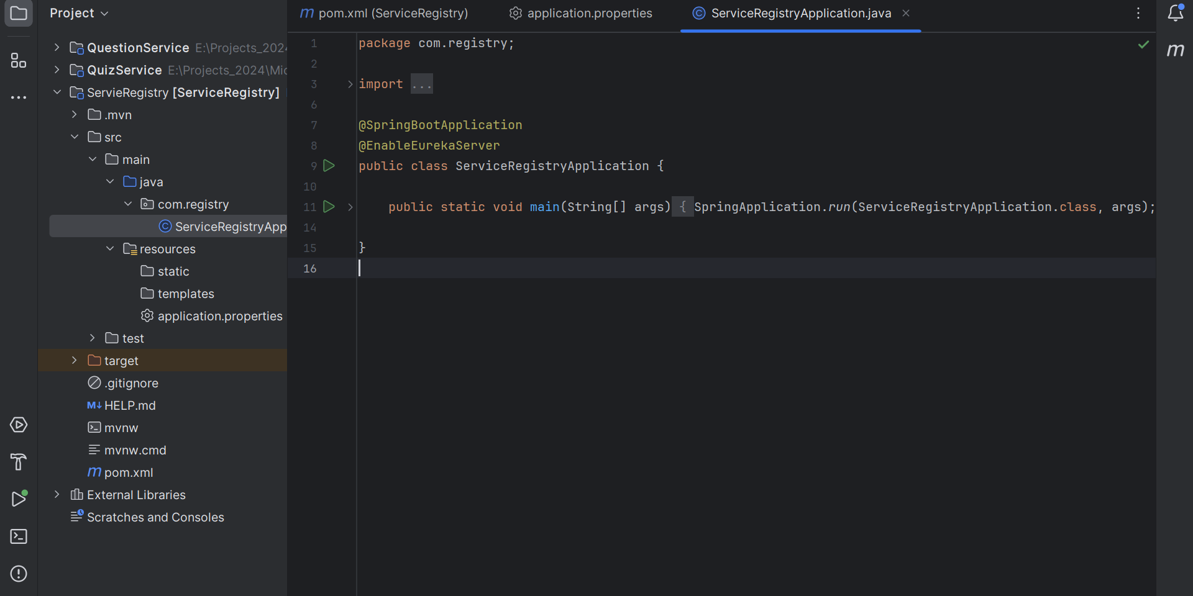

Added dependency in quiz pom.xml

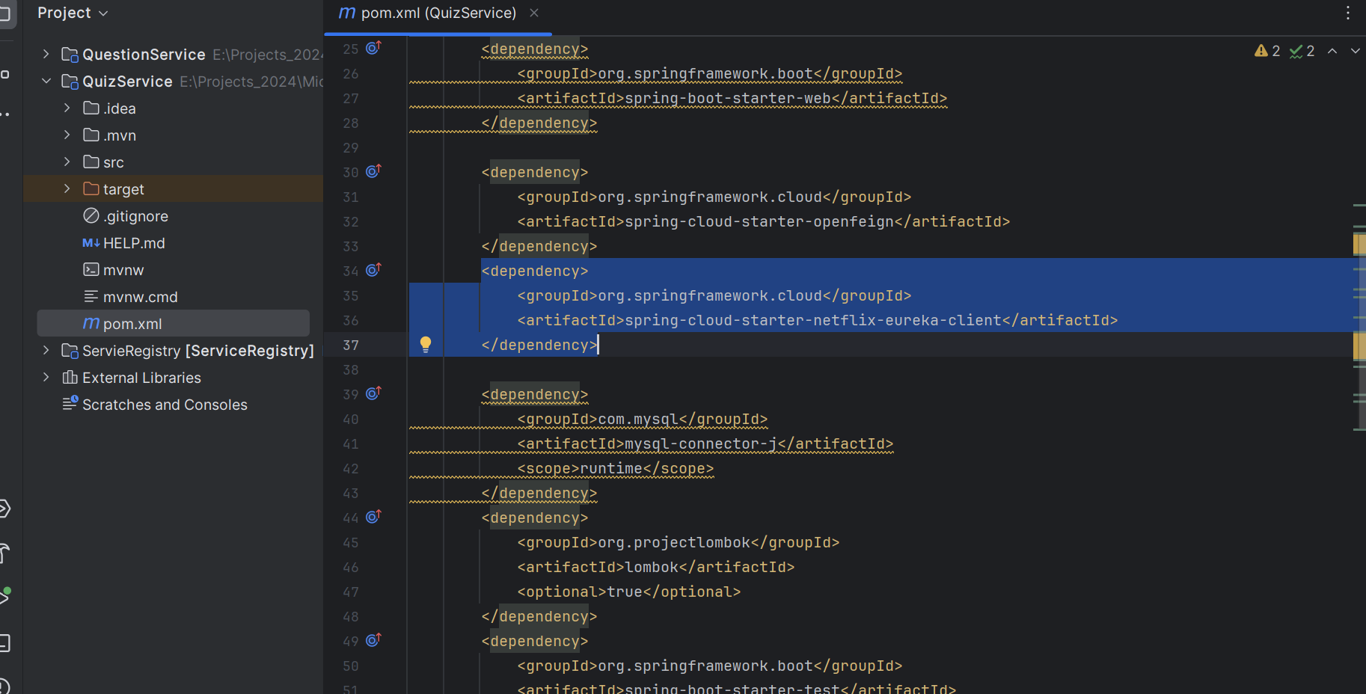

Add both in quiz service in application.properties file.

spring.application.name=QUIZ-SERVICE

eureka.instance.client.serverUrl.defaultZone=http://localhost:8761/eureka/

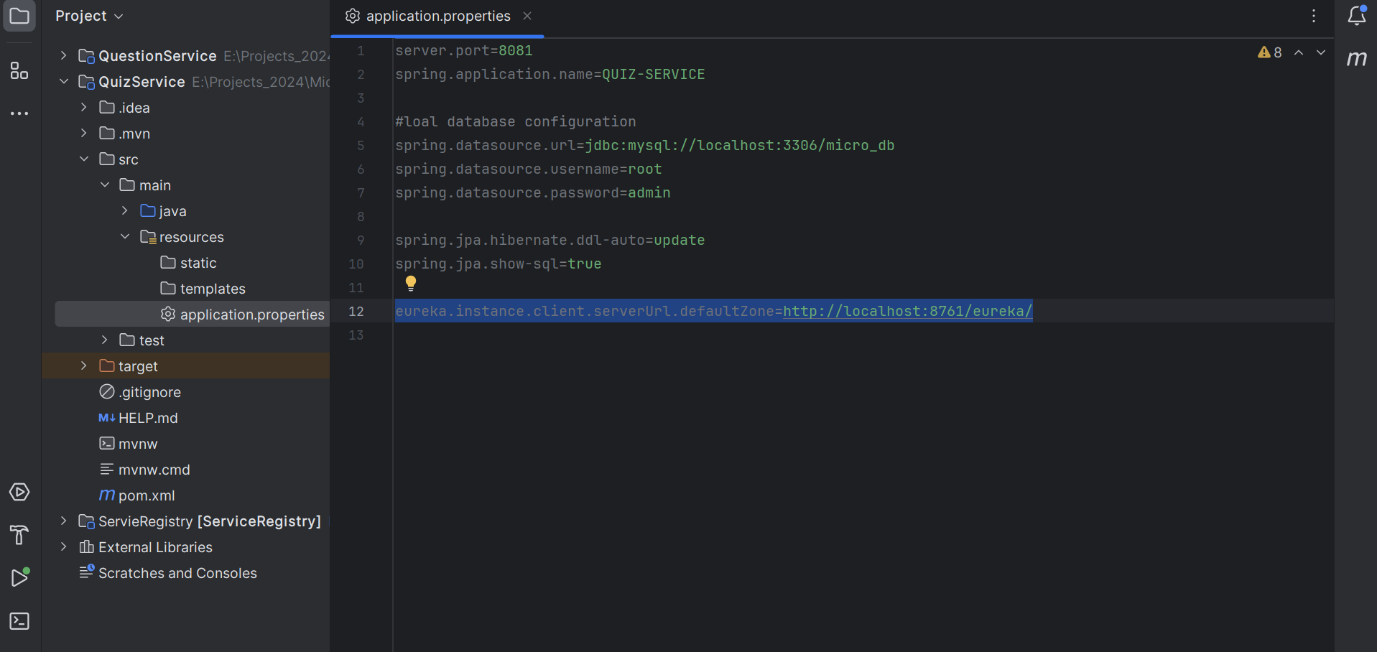

Same thing do in question service

Add dependency management

Add version

Add client

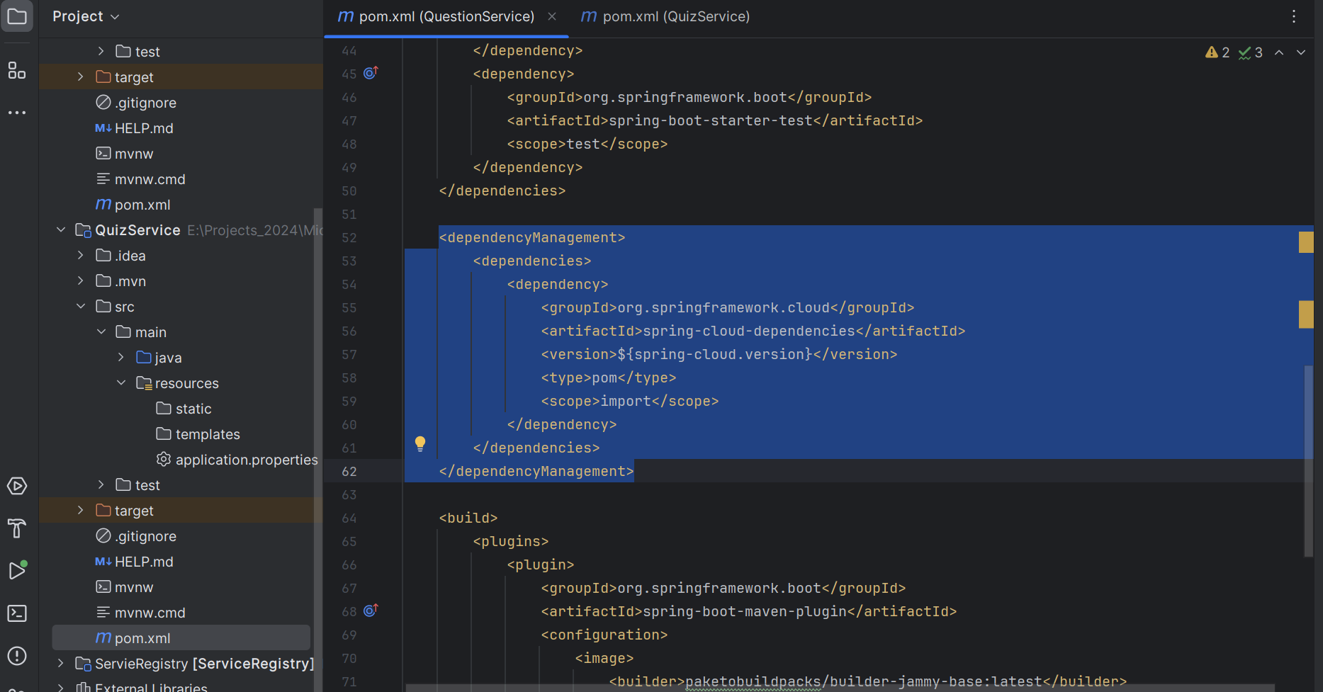

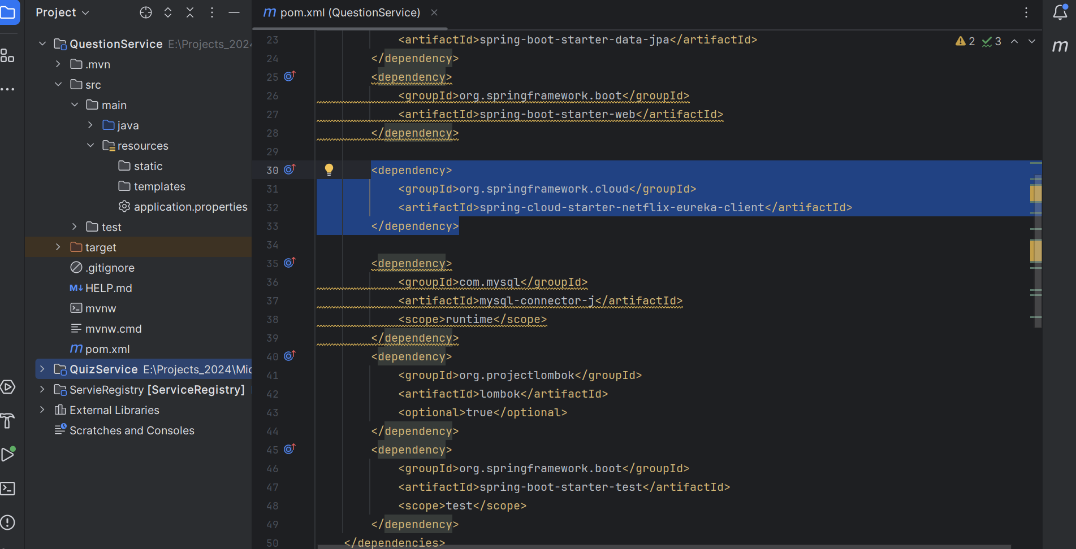

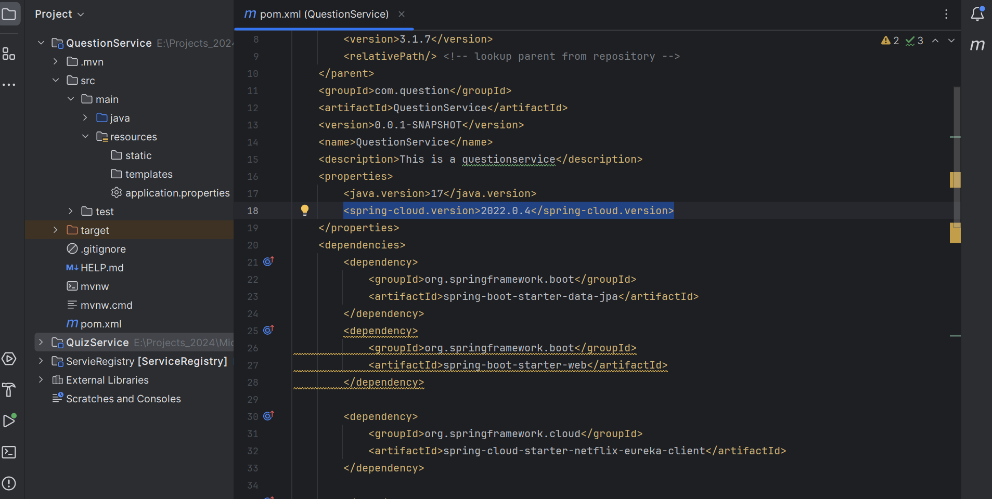

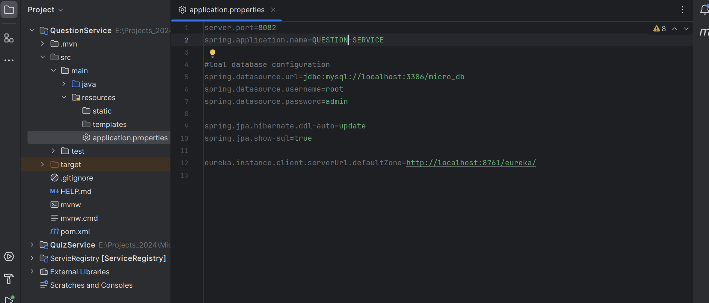

Now fire the URL: <http://localhost:8761/>

And see the below status.

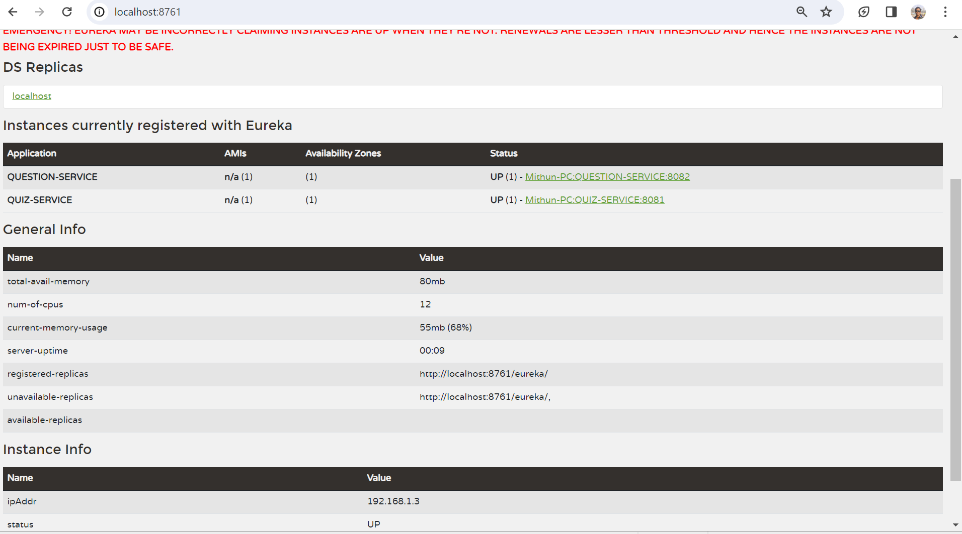

Load Balancer

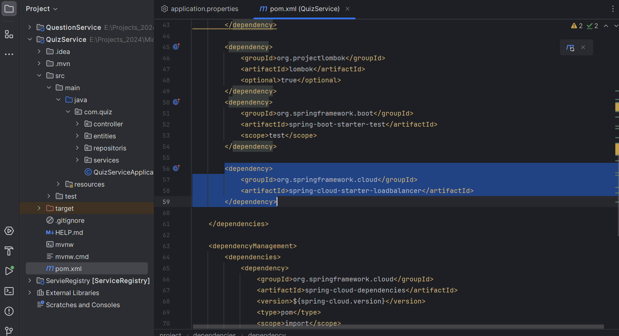

**API Gateway**

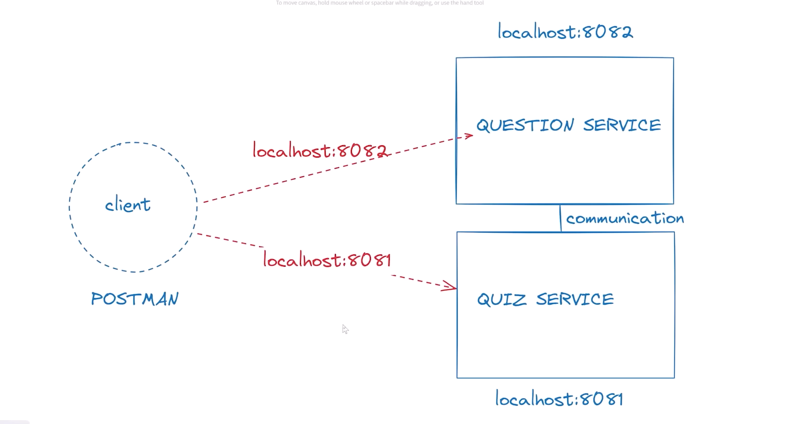

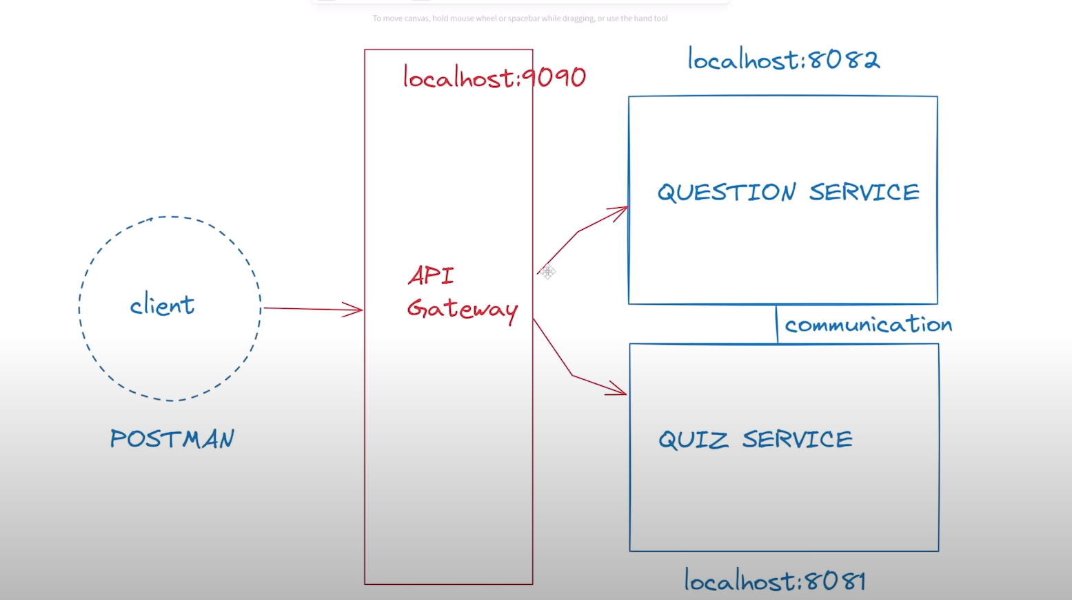

API Test

GET: <http://localhost:8083/question>

GET: <http://localhost:8083/question/1>

GET: <http://localhost:8083/quiz>

GET: http://localhost:8083/quiz/1